7.1 APPENDIX 1

Fact sheet Action Research Brussels
Group composition | 6 participants
Number of meetings | 9
duration | 18/12/07 – 04/02/09 (1 year and 2 months)

Needs analysis
(two meetings)

In Brussels the needs analysis was very extensive. The main topic the elderly discussed was the usability of public transport in the city. By this the elderly meant the accessibility of the railway, the metro and the bus, both the stations and the vehicles. Next to the accessibility also the information services and traffic safety were mentioned. The feeling of insecurity at the PT in Brussels was very high, especially in the evening. Most of the participants didn’t go at alone at night by public transport. This was not only caused by the people hanging around in the stations or at the bus stops, but also by the bad lights and the long, empty doorways with a lot of corners.
Also courtesy and respect were seen as a large issue, e.g. youngsters with bag packs, giving up one’s place for older or disabled people, swarming, not letting people on or off the bus.
In a large city like Brussels the liveability was seen as a problem as well, it’s noisy, there is a lot of congestions and the elderly feel people don’t follow the traffic rules.

Action
(five meetings)

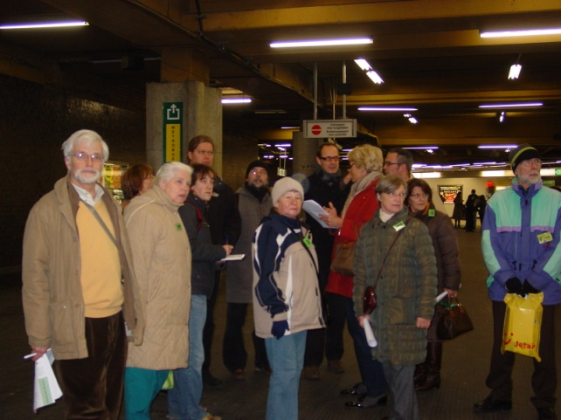
Both courtesy and user-friendly public transport were very important. Choosing one of the themes was hard as the elderly felt these topics are connected to each other. The participants decided to organise a round trip through public transport in Brussels with PT-providers and the authorities. A few general remarks were listed as well as sit-specific reamers. They had drawn up a list of bottlenecks and related places. Based on this list the steering committee mapped out a route. The elderly invited representatives of the NMBS, MIVB and De Lijn and the minister of mobility of the Brussels Capital Region. Although the latter was very interested to take part in the site-visit, his agenda didn’t allow this and he was represented by one of his staff members. The minister himself invited the elderly for a meeting at his office to discuss the most important bottlenecks. The representative of MIVB wasn’t present at the site-visit, but did make it to the meeting with the minister.

Evaluation
(one meeting)

The participants were pleased with the site-visit and the meeting with the minister. They had the feeling that a lot of the problems were known by the authorities and that projects to solve some of them were already in the pipeline. The core-group of the steering committee thought process was going too slow. Several participants came only once or twice and they often discussed topics that were already considered at previous meetings by the rest of the steering committee. The representative had hoped to have a more structured, coherent and general discussion with the minister. The elderly didn’t perceive the meeting as poor structured and too detailed. Contacts were made between the senior centre and the PT-providers, which could be very interesting for exchanging information and experiences in the future.

The tour on the Brussels PT-system.
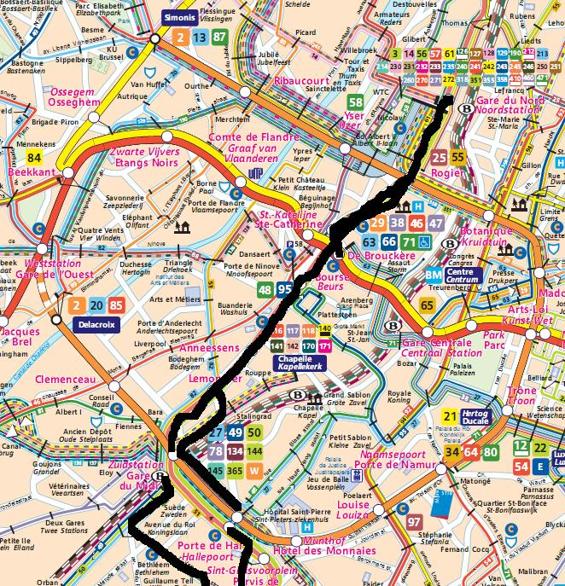

Fact sheet Action Research Gembloux

Group composition | 7 participants
Number of meetings | 6
duration | 11/04/08 – 20/02/09 (8 months)

Needs analysis
(one meeting)

The needs analysis in Gembloux was slightly different from the other action research sites. During the information sessions, the elderly already told about there wish to conduct a survey in order to learn about the problems and irritations the elderly of Gembloux perceive.
Although this was the starting point of the meetings, the elderly talked about some bottlenecks during the meetings.
Concerning accessibility, a lack off and poor infrastructure of foot paths was mentioned as well as the literal accessibility of the train (gap between train and platform). More in general the access of the new shopping area was a big issue. The new area has a poor connection with public transport, which has a large impact for the elderly.
Secondly, the participants talked about feelings of insecurity, with a combination of social insecurity and traffic safety, e.g. high speed of cars, feelings of insecurity in tunnels, lack of foot paths etc. Also noise and irritations due to traffic and lack of participation of elderly in the local policy was mentioned.

Action
(three meetings)

The different problems mentioned, were used to determine topics for the questionnaire. Based on these problems, a draft questionnaire was drawn up by the researchers. The draft questionnaire was discussed but the majority of the remarks came from the city worker. The city worker didn’t leave much room for the elderly to give their opinion. A new draft was drawn up and discussed once again, this time the elderly the input of the elderly was even less, e.g. the city worker decided unilaterally to have one extra open qualitative question. The city would process this question themselves. The questionnaire were returned to the researchers two months later. The results were presented into a brief and understandable report for the elderly and a date was fixes to present the results to the steering committee. The result showed different problems. Because the chairman of the commission of elderly and the city worker were not pleased with the quality of the report (language and statistics not detailed enough), this meeting was cancelled. In a meeting with these representatives the expectations of the city and possibilities within the MESsAGE project were geared to each other. The city decided to re-run the data and write a statistical report themselves, while the researchers made a powerpoint presentation that was understandable and clear to present to the elderly. At the end of the project (April 2009), the researchers were still waiting for the city to finish their report and present the results to the elderly.
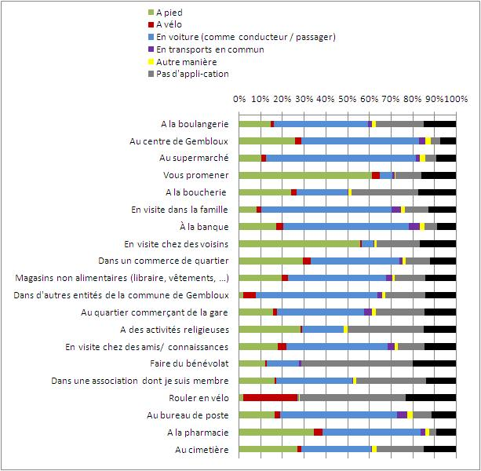

Evaluation

No evaluation meeting was held with the participants as the action was not finished yet. Because the researchers don’t have the contact details of the individual elderly, they couldn’t ask for their opinion of the results nor conduct the evaluation of the action.

Fact sheet Action Research Leuven

Group composition | 7 participants
Number of meetings | 11
duration | 20/03/08 – 08/12/08 (9 months)

Needs analysis
(one meeting)

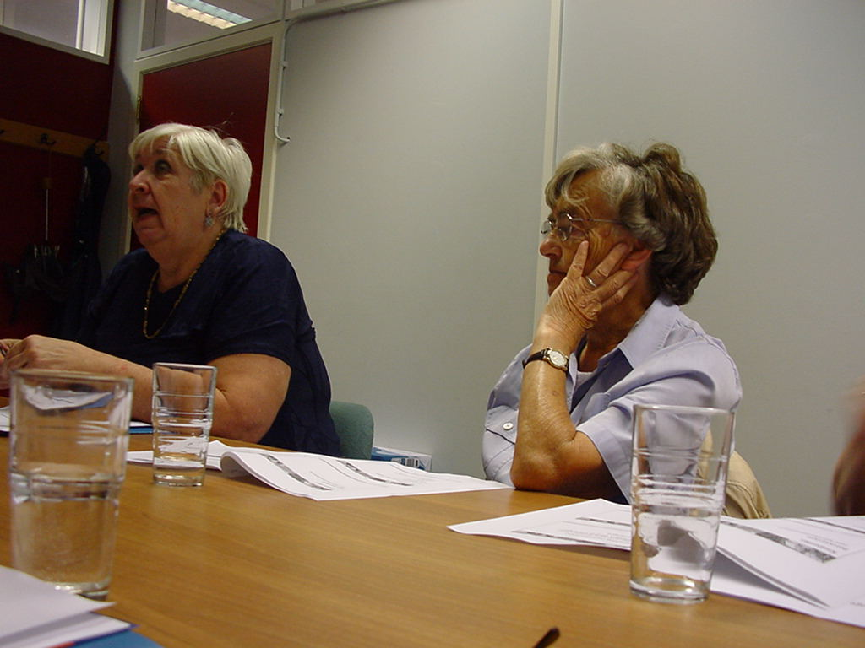
In Leuven the elderly encountered a lot of problems related to accessibility: problems with bad infrastructure of foot paths, lack of cycling lanes, bad lights at small paths, poor infrastructure of bus stops and difficulties with the timetables of public transport.
Concerning liveability the behaviour of bus drivers was mentioned as well as courtesy on public transport, but also of students cycling through the city. The courtesy issues on PT was the same as mentioned in other action researches: bag packs, give up seats for elderly and disabled, respect for the infrastructure (buss stops as well as busses).
Two other problems for the elderly were a feeling of insecurity at some places in Leuven and the wish for more participation related to mobility.

Action
(eight meetings)

The elderly agreed that most of the problems they talked about were related to courtesy. Although also they think this topic is mainly a responsibility of parents and educators, they wanted to find a way to raise awareness on courtesy themselves. Therefore the steering committee decided to produce cartoons on courtesy and distribute this with leaflets and posters in busses and schools. They asked De Lijn to uptake their project. Next to this, the elderly took the opportunity to present the action at the open days of the Council of Senior citizens and talk to their peers on these days to ask for their problems, irritations and needs concerning public transport in Leuven.
During the Week of the Senior Citizens the leaflets were distributed, the poster campaign ‘Look, another one with attitude!’ at the busses was conducted and the action was presented at the open days. Also in the media (regional radio and television) the action was announced.

The poster designed by the action research group of Leuven.
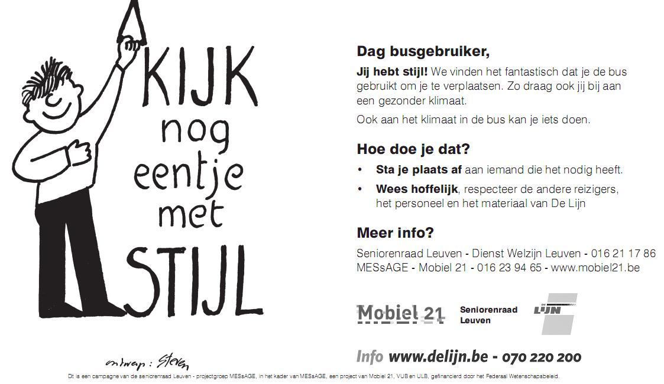

Evaluation
(one meeting)

Although the majority of the participants joined the action group to talk about foot paths. The action was evaluated positively. The open days were considered interesting, the elderly could talk to their peers. The elderly sometimes have the feeling they can’t chance things anymore, but in this project, they felt they took part in something useful and that the group of elderly counts. Doing small things, like this action, makes a difference, according to the elderly. The participants stress the importance to have the support of the authorities and to work together with partners as De Lijn.

TV-uitzending ROB-nieuws 16/12 17u30

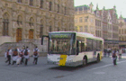
Kijk nog eentje met stijl !
Hoffelijkheid op de bus. Daar ijvert de Leuvense vzw Mobiel 21 samen met de Leuvense senioren voor. In december zal je op alle Leuvense bussen de boodschap ‘Kijk nog eentje met stijl!’ zien hangen. Want volgens Mobiel 21 is er steeds minder aandacht voor oudere mensen op de bus.
Meer aandacht voor ouderen en meer hoffelijkheid op de Leuvense bussen, daar draait de decemberactie van de vzw Mobiel 21 rond. Om de actie kracht bij te zetten namen drie Leuvense senioren van Mobiel 21 dinsdag de bus aan het Leuvense station.
Met de slogan 'Kijk, nog eentje met stijl!' op flyers en affiches willen de senioren een oproep doen om wat meer respect voor het personeel en materiaal op de bus. Of om gewoon eens een plaatsje af te staan aan iemand die niet goed te been is.

De hele maand lang loopt de campagne van Mobiel 21 en de Leuvense seniorenraad nog

Fact sheet Action Research Mons

Group composition | 6 participants
Number of meetings | 8
duration | 06/02/08 – 18/11/08 (9 months)

Needs analysis
(two meetings)

In Mons a lot of bottlenecks were encountered. Concerning accessibility, the three basic problems the elderly mentioned were a bad infrastructure of the foot paths, lack of courtesy from youngsters towards elderly and bad adaptation of Public Transport towards elderly. The most important issues for liveability were the noise, the high speed and the feelings of insecurity. Concerning traffic safety the elderly found the traffic dense, tunnels have the connotation to be dangerous, time to cross the streets at save pedestrian crossings is to short and a lot of congestion at schools. In the field of participation, the elderly feel participation of elderly in policy is limited. They feel the local authorities don’t listen to them. The also have the feeling public services aren’t for the benefit of the people anymore.
After a long discussion the elderly

Action
(four meetings)

The prior problems for the participants were poor infrastructure or infrastructure not geared to the needs of the elderly and courtesy and attitude, as well of youngsters as of the authorities and the police. Therefore the steering committee decided to organise a participative meeting with the authorities. The elderly felt it was needed to inform them on the daily problems they have to deal with. They agreed to invite the aldermen of Public Works, Mobility and Social Affairs, the mayor and the architect of the Platform of Disabled People. The presentation used for the meeting would consist of an introduction with the results of the State-of-the-art of MESsAGE, a slideshow with pictures of bottlenecks based on own experiences, problems and needs and a conclusion with a few recommendations. The elderly took the pictures themselves and discussed the problems and recommendations during a preparatory meeting. Before the meeting could be organised the city workers had to prepare a technical description on the bottlenecks and recommendations the authorities had to approve. The file was handed over to the responsible authorities, but no confirmation had been received by the end of the project (April 2009).

Some pictures from the presentation
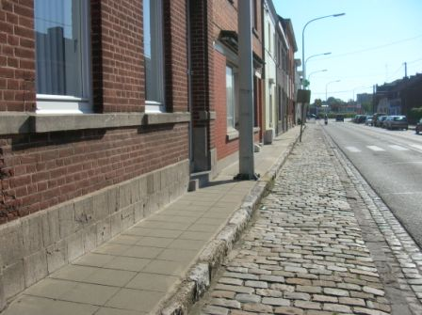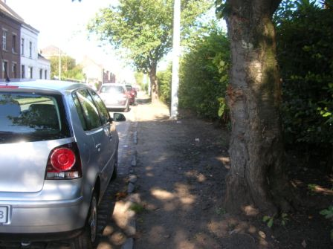
obstacles on the sidewalk sidewalk in bad condition

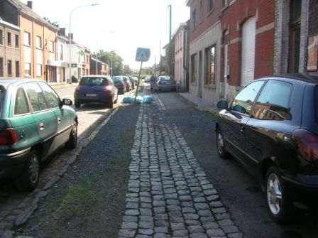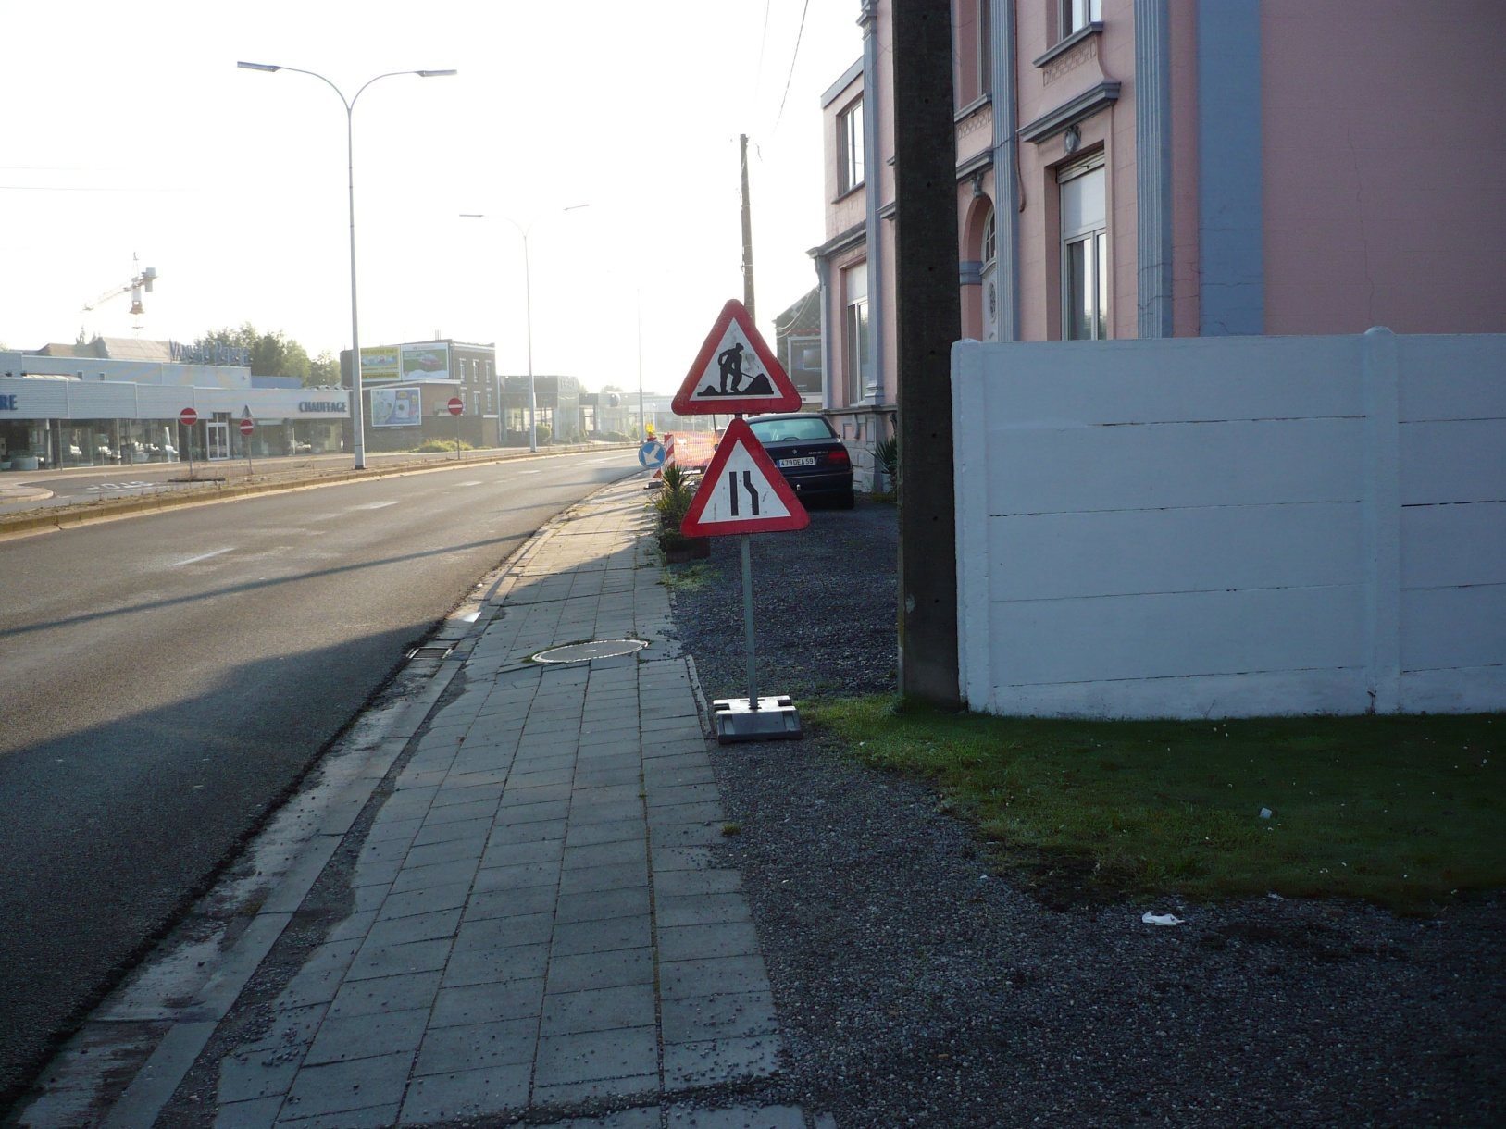
illegally parked cars sidewalk, bad condition and dangerously steep

Evaluation

No evaluation meeting was held with the participants as the action was not finished yet. The researchers contacted the city workers several times, but as long as the technical file hasn’t been approved the meeting can’t be organised.

Fact sheet Action Research Sint-Truiden

Group composition | 8 participants
Number of meetings | 6
Duration | 25/09/07 – 15/04/08 (7 months)

Needs analysis
(one meeting)

The first and one of the most important bottlenecks encountered was youngsters and courtesy at public transport: lying on couches, bag packs or shoes on couches, stand your place to elderly, …The elderly of the steering committee feel a change in mentality at the expense of their group.
The accessibility was another bottleneck, especially of the small parishes are perceived as not reachable with public transport. After a short discussion it appeared that the supply is sufficient, but that the information on e.g. call-the-bus or the service for the less mobile, doesn’t reach the elderly. Therefore the target group specific information was seen as an important issue. In this context also information on the parking policy in Sint-truiden was mentioned.

Results of the survey amongst elderly citizens in St-Truiden on communication channels

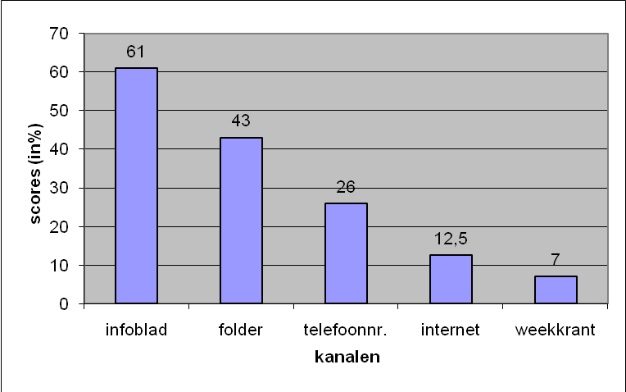

Action
(three meetings)

The steering group agreed unanimous to do an action of target group specific information. Firstly, the elderly conducted a survey amongst their peers on two questions:
- What do you want to know about mobility in Sint-Truiden?
- How should this information reach you, through which information channels?
Based on the results of this questionnaire, the steering committee decided to write articles for the city magazine in order to inform elderly, but also other interested citizens, on following topics: general information on mobility in Sint-Truiden, bus lines in the centre of Sint-Truiden, bus lines to the parishes around Sint-Truiden, using the train, how to find information on the internet and information on the call-the-bus service. All articles were published in the city magazine between April and October 2008.

Articles were published in the city magazine
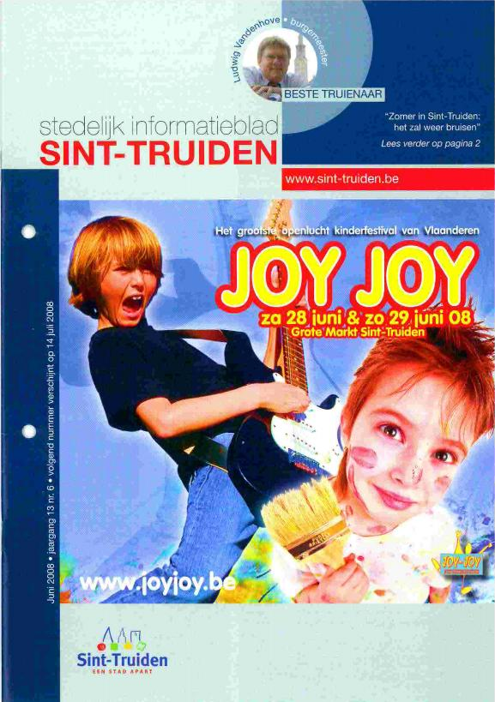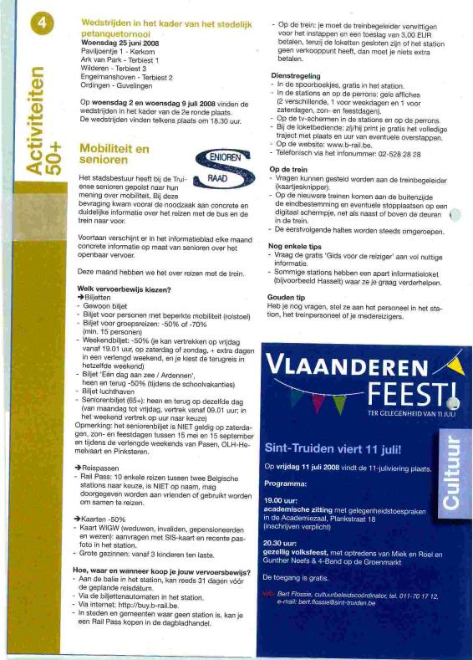

Evaluation
(one meeting)

The elderly evaluated the action and the action research positively. At the evaluation meeting (April 2008), they asked for an impact evaluation at the end of the project. The researchers had sent out a evaluation survey to the participant in order to distribute this amongst their peers and sent it back, but the researchers didn’t got any q

